GLOBAL SALES AND FINACIAL PERFORMANCE DASHBOARD
POWER BI
PROJECT REPORT(WEEK – 2)

Student Name | Metha Shree B
Register Number | E25FA024
Course | B.Com Fintech & AI
Project Title | Global Sales Performance Dashboard
Academic Project | Sales Data Analysis & Visualization

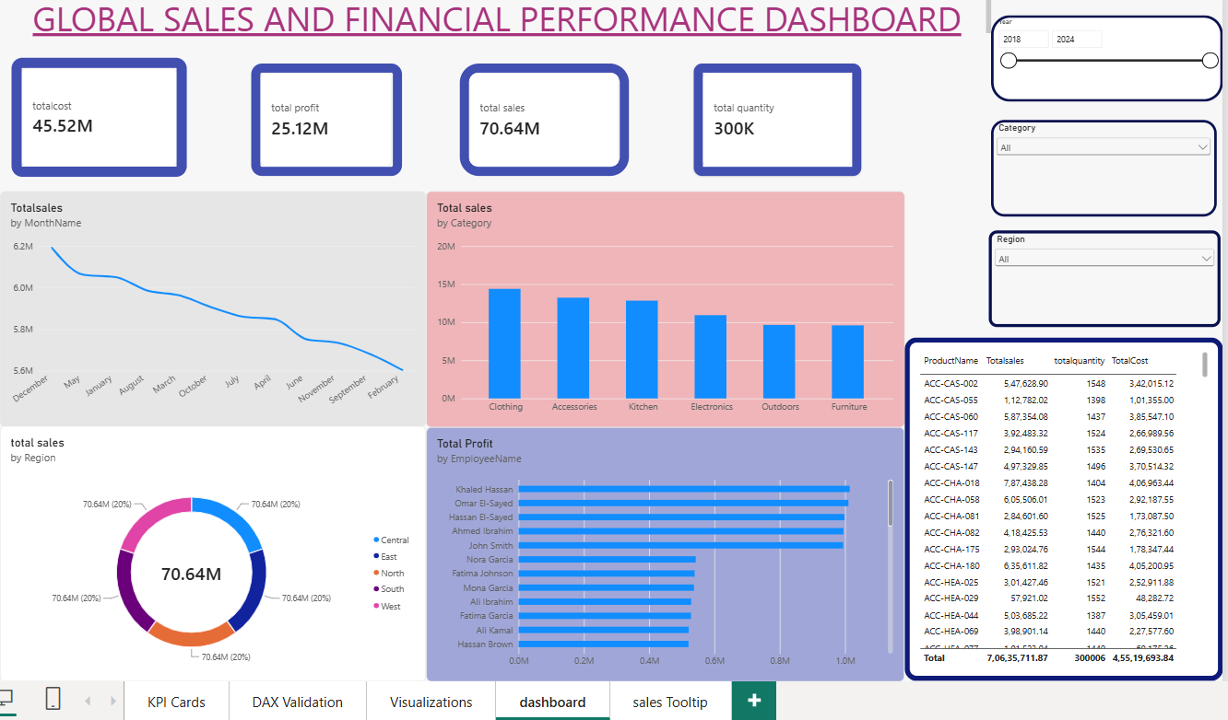

- INTRODUCTION:-
For this project, I explored a Power BI report built around sales and financial performance data, with the goal of understanding not just what the numbers say, but how effectively a dashboard can turn raw business data into something a decision-maker can actually act on. Dashboards like this one are meant to bridge the gap between large volumes of transactional data and the quick, confident decisions that managers and analysts need to make on a daily basis without needing to dig through spreadsheets or write queries themselves.
Working through this report gave me a practical sense of what goes into building such a tool: cleaning and structuring data, defining accurate calculations, and then presenting everything in a way that's clear at a glance. It also highlighted how easy it is for small inconsistencies in naming, formatting, or logic to creep in during development, and why validation and review matter just as much as the initial design.
The purpose of this assignment is to critically evaluate this dashboard as a real business user would is the information reliable, is it presented clearly, and does it genuinely make understanding sales and financial performance easier and faster than working with the underlying data directly.

2) OBJECTIVES:-

The main objectives I set out to achieve with this project were:
- Build a star schema data model with Fact Sales and four dimension tables (Customer, Product, Employee, Geography, Date) .
- Create DAX measures for Total Sales, Total Profit, Total Quantity, Total Cost, and Average Sales .
- Analyze profit by Employee using a clustered bar chart .
- Analyze sales distribution by Region using a donut chart.
- Track sales trend over time (by Month) using a line chart .
- Add interactive slicers for Year, Category, and Region .
- Combine all elements into a single interactive dashboard .
- Design custom tooltips for enhanced data exploration .
- Demonstrate complete Power BI workflow: data import → modeling → DAX → visualization → dashboard.

3) DATASET DESCRIPTION:-

FIELD | TYPE / ROLE | PURPOSE IN ANALYSIS
Sales Key | Primary Key | Uniquely identifies each sales transaction
Order DateKey | Foreign Keys | Link FactSales to respective dimension tables
Quantity | Measure | Units sold; used for volume analysis
Sales Amount | Measure | Core revenue metric
Total Cost | Measure | Used for profitability calculations
Profit | Measure | Key performance metric
Channel | Attribute (Categorical) | Sales channel & payment trend analysis
Customer Name | Attribute | Customer profiling & segmentation
ProductName | Attribute | Product-level and category-wise analysis
Employee Name | Attribute | Performance analysis by staff/role
Country / Region / City | Attribute | Geographic/location-based analysis
Date | Attribute (Date) | Time-based trend analysis

This structure made it possible to slice the data in a lot of different ways by store, by time period, or by holiday status which is exactly what I needed for the kind of comparisons I wanted to make in my dashboard.

4) DATA PREPARATION:-
Before I could start building any visuals, I had to make sure the data was clean and properly structured. Here's what I did:
Data Preparation
i)Data Source
Six CSV files imported from a local folder — "Global Sales & Financial Performance Dataset" — covering Customers, Products, Employees, Geography, Date, and Sales transactions.
ii)File Import
Each CSV loaded using Csv.Document with comma delimiter and standard encoding (1252), ensuring consistent parsing across all source files.
iii)Header Promotion
Applied Table.PromoteHeaders on every table to convert the first row of each CSV into proper column headers.
iv)Data Type Conversion
Used Table.TransformColumnTypes to explicitly assign correct data types to each column:
  - Numeric keys (e.g., CustomerKey, ProductKey, EmployeeKey, GeographyKey, DateKey) → Whole Number
  - Currency/measure fields (e.g., SalesAmount, Profit, TotalCost, UnitPrice, ListPrice) → Decimal Number
  - Date fields (e.g., SignupDate, HireDate, Date) → Date
  - Boolean flags (e.g., IsWeekend, IsHoliday) → Logical (True/False)
  - Descriptive fields (e.g., CustomerName, ProductName, Category, Region) → Text.
v)Table Structuring
Organized data into a star schema — one fact table (FactSales) and five dimension tables (DimCustomer, DimProduct, DimEmployee, DimGeography, DimDate).
vi)Relationship Building
Established relationships between FactSales and each dimension table using key columns (CustomerKey, ProductKey, EmployeeKey, GeographyKey, OrderDateKey) to enable cross-table filtering and analysis.
vii)Data Validation
Cross-checked prepared measures against raw values (via the DAX Validation table) to confirm accuracy after transformation.
viii)Load to Data Model
Final cleaned and typed tables loaded into the Power BI data model for building measures and visuals.

5)DAX Measures with Formulas:-
Measure Name | DAX Formula | Use
Total sales | SUM(FactSales[SalesAmount]) | Calculates overall revenue generated; used in KPI cards, charts, and dashboard for total sales tracking
Total profit | SUM(FactSales[Profit]) | Calculates total net profit earned; used to measure profitability by employee, region, and overall performance
Total quantity | SUM(FactSales[Quantity]) | Calculates total units sold; used to track sales volume across products/categories
Average | AVERAGE(FactSales[SalesAmount]) | Calculates the average sale value per transaction; used for identifying typical order size
Totalsales | SUM(FactSales[SalesAmount]) | Same as "total sales"; used in the DAX Validation table to cross-check accuracy at product level
Totalquantity | SUM(FactSales[Quantity]) | Same as "total quantity"; used in the DAX Validation table for verifying unit counts
Totalcost | SUM(FactSales[TotalCost]) | Calculates total cost incurred; used in KPI cards and validation to assess cost impact on profit
Average sales | AVERAGE(FactSales[SalesAmount]) | Same as "average"; used for customer-level average transaction analysis

6)Data Components and visualizations used:-
i)Fact Table
  - FactSales – contains transactional sales data (Quantity, UnitPrice, Discount, SalesAmount, TotalCost, Profit, Channel, PaymentMethod, OrderPriority)
ii)Dimension Tables
  - DimCustomer – customer details (Name, Email, Phone, SignupDate, LoyaltyTier, Gender)
  - DimProduct – product details (Name, Category, SubCategory, Color, Size, StandardCost, ListPrice)
  - DimEmployee – employee details (Name, HireDate, Role)
  - DimGeography – location details (Country, Region, City)
  - DimDate – calendar attributes (Year, Quarter, Month, MonthName, Day, DayOfWeek, IsWeekend, IsHoliday)
iii)Keys / Relationships
  - Primary Keys: CustomerKey, ProductKey, EmployeeKey, GeographyKey, DateKey
  - Foreign Keys in FactSales linking to each dimension table
  - Relationship type: One-to-Many (Dimension → Fact)
iv)Measures (Calculated Fields)
  - Total Sales, Total Profit, Total Quantity, Total Cost, Average Sales — created using DAX
v)Calculated/Validation Table
  - DAX Validation table cross-checking measure outputs against raw values at product level
vi)Visual Components
  - KPI Cards, Clustered Column Chart, Clustered Bar Chart, Donut Chart, Line Chart, Table, Slicers, Tooltips.
Visuals used:-

Charts:-
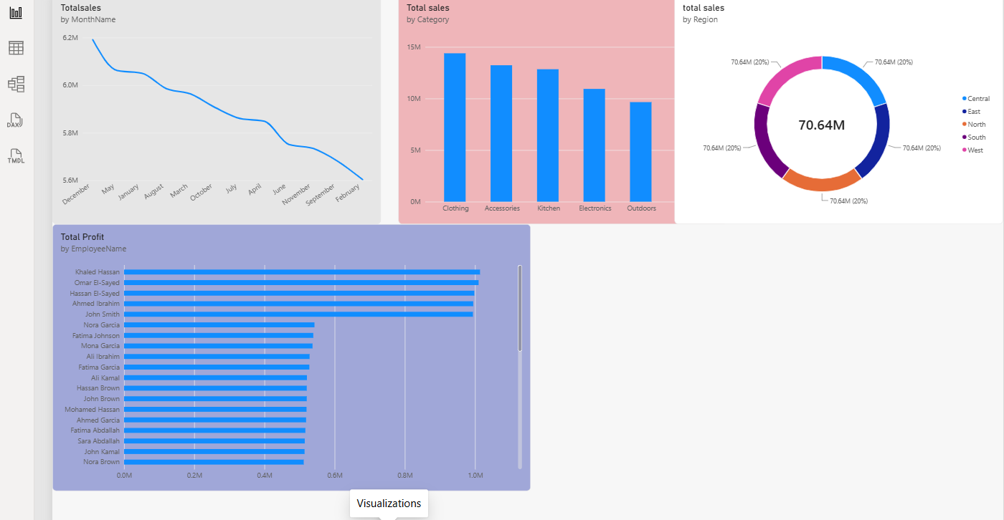
Sales Tooltip
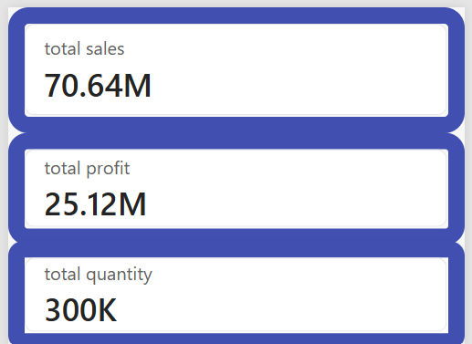
7) KPI Cards:-
KPI Cards acts as an executive summary — the first thing a viewer sees to gauge overall sales health (revenue, cost, profit, and volume) in one glance. Each card has a rounded border (radius/width styled individually) with a subtle theme-colored outline; one card also has a background fill and drop shadow for visual distinction.
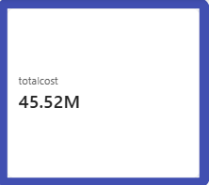
This card shows the Total Cost KPI, displaying 45.52M — the total cost incurred across all sales transactions.
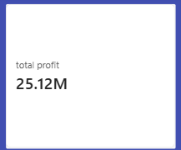
This card shows the Total Profit KPI, displaying 25.12M — the total net profit earned across all sales.
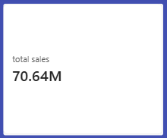
This card shows the Total Sales KPI, displaying 70.64M — the total revenue generated across all sales transactions.
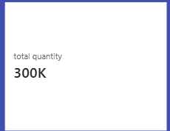
This card shows the Total Quantity KPI, displaying 300K — the total number of units sold across all sales transactions.

8) Summary Table:-
The KPI Cards page shows four key totals for the entire dataset: Total Profit is about ₹2.51 crore, Total Sales is about ₹7.06 crore, Total Quantity sold is around 3 lakh units, and Total Cost is about ₹4.55 crore. Together, these give a quick snapshot of overall business performance at a glance.
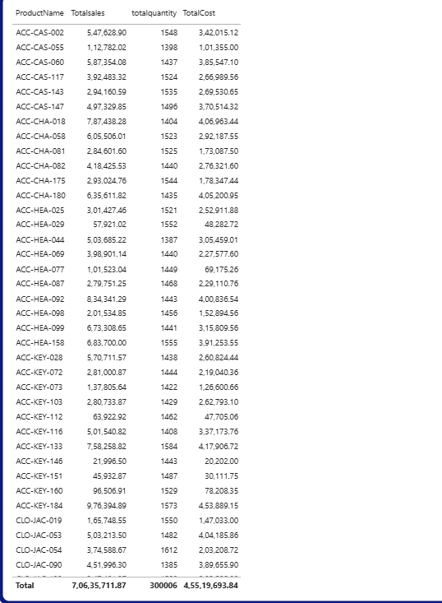

9) Dashboard Screenshot:-

10) Key Findings:-
- Total Sales: ₹7.06 crore with Total Profit: ₹2.51 crore — an overall profit margin of ~35.6%, indicating healthy profitability.
- Sales are almost evenly distributed across regions, with Central region leading in profit (₹50.7 lakh), closely followed by West, South, North, and East — no single region dominates.
- Sales channels are nearly balanced — Partner, Retail, Online, and Phone each contribute roughly ₹1.75–1.78 crore, showing no over-dependence on a single channel.
- December, May, and January are peak sales months, suggesting a mild seasonal boost around year-end/holiday and early-year periods; February shows the lowest sales.
- Top-performing employees (Khaled Hassan, Omar El-Sayed, Hassan El-Sayed) each generated over ₹9.9 lakh in profit, highlighting relatively consistent performance among top sales staff rather than one standout outlier.
- Total quantity sold: ~3,00,006 units, averaging roughly ₹235 per unit sold across the year.

11) RECOMMENDATIONS:-

- Stock up and staff up in advance for December, May, and January when sales peak .
- Introduce discounts or campaigns to fix the seasonal dip.
- Compare Online, Retail, Partner, and Phone to invest more in the highest-margin channel .
- Study techniques of high-profit employees and share best practices across the team .
- Analyze cost/demand factors to close the small gap with other regions .
- Fine-tune pricing and discounts to boost margin beyond the current ~35.6% .
- Merge repeated measures (e.g., "total sales" vs "Totalsales") for a cleaner model .
- Leverage LoyaltyTier and Gender fields for better segmentation and retention campaigns.
12) CONCLUSION:-
This project shows how raw sales data can be transformed into a clear, interactive Power BI dashboard using proper data modeling and DAX measures. It successfully tracks key metrics like sales, profit, quantity, and cost, while allowing users to explore performance by category, region, employee, and time period. Overall, the dashboard achieves its goal of turning data into meaningful, easy-to-understand business insights for better decision-making.

